IPC Display Layout Selection Control Function – CGEA 1.3

Functional Description

This STSS describes the selection of the IPC Display Layout. This STSS is applicable when the cluster has more than one display layout. The IPC Display Layout Menu consists of a list of IPC Display Layouts that can be selected by the vehicle occupant. Once an IPC Display Layout Menu item is selected, the cluster display will be updated to the selected IPC Display Layout.

The IPC Display Layout Menu can vary from program to program and a program specific IPC Display Layout Menu List will be specified in a program specific IPC Menu Structure file. Each IPC Display Layout Item will have an associated graphic layout specified in a program specific Wallpaper file. One IPC Display Layout item will be designated the battery connect default and it will be assigned IPC_Dsply_Layout value of 0x0. The selected IPC Display Layout will be retained during a Key Cycle.

Interfaces

Interface Context Diagram (I/O Block Diagram)
- IPC Display Layout Selection Control Function Context Diagram
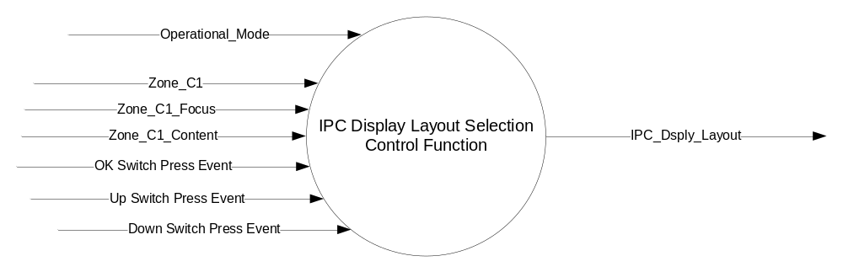

Inputs

- INTERNAL:
- Operational_Mode
- OK Switch Press Event
- Up Switch Press Event
- Down Switch Press Event
- Zone_C1
- Zone_C1_Focus
- Zone_C1_Content

Outputs
- IPC_Dsply_Layout, variable to identify the currently selected IPC Display Layout

Function/Performance

Operational Modes

Mode | Differentiating Vehicle Conditions
Sleep Mode | IPC Display Layout Selection Control Function Disabled
Limiting Mode | IPC Display Layout Selection Control Function Disabled
Normal Mode | IPC Display Layout Selection Control Function Enabled / Disabled
Crank Mode | IPC Display Layout Selection Control Function Enabled / Disabled

Voltage Levels

Refer to the Cluster Features table located in the Operational Modes and Voltage Range Strategies Section in this SPSS.

Human-Machine Interface

Visual

Indicator Graphics / Display Format
Refer to “<Program> Cluster Menu Structure.xls”.
This is an example of a layout from a program specific Menu Structure file.

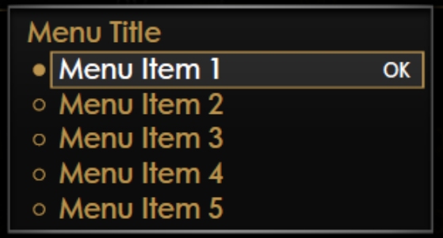

 |  |  |  | AHUD_Status_Bar_MC_Status = 0x0 (Off) |  |  |  | AHUD_Status_Bar_MC_Status = 0x1 (On)
IPC_Dsply_Layout | IPC_Dsply_Layout Menu Item Text |  | F2 Content |  | G1 Content | G2 Content | F2 Content |  | G1 Content | G2 Content
0x0 | Calm |  | Time and Temperature |  | DTE | Compass and Street Name | Compass and Street Name |  | Blank | Blank
0x1 | Economy |  | Time and Temperature |  | Average and Instantaneous Fuel Economy w/DTE | Compass and Street Name | Compass and Street Name |  | Average and Instantaneous Fuel Economy | Blank
0x2 | Classic |  | Compass Heading, Time, and Temperature |  | Tachometer w/DTE | Boost and Temperature Gauges | Compass and Street Name |  | Tachometer | Boost and Temperature Gauges
0x3 | Not Used |  | Not Used |  | Not Used | Not Used | Not Used |  | Not Used | Not Used
0x4 | Not Used |  | Not Used |  | Not Used | Not Used | Not Used |  | Not Used | Not Used
0x5 | Not Used |  | Not Used |  | Not Used | Not Used | Not Used |  | Not Used | Not Used
0x6 | Not Used |  | Not Used |  | Not Used | Not Used | Not Used |  | Not Used | Not Used
0x7 | Not Used |  | Not Used |  | Not Used | Not Used | Not Used |  | Not Used | Not Used

Indicator Color Coordinates

Reference Ford HMI or Studio Wallpaper files for the specific program.

Indicator Characteristics

Reference Ford HMI or Studio Wallpaper files for the specific program...

Audio

None

Switch Control Logic

Consumer access to the IPC Display Layout Selection Control Function shall be as specified in the message center basic functionality display as specified in Message Center STSS. The Switch logic while the IPC Display Layout Menu is the active display is also in this STSS.

System Accuracy

Within a 100msec of receiving a message that results in a change of state the cluster will update the display to the proper status.

Operation: Performance and Functional

Subsystem Algorithm Flowchart / State Diagram
- IPC Display Layout Selection Control Function Flowchart
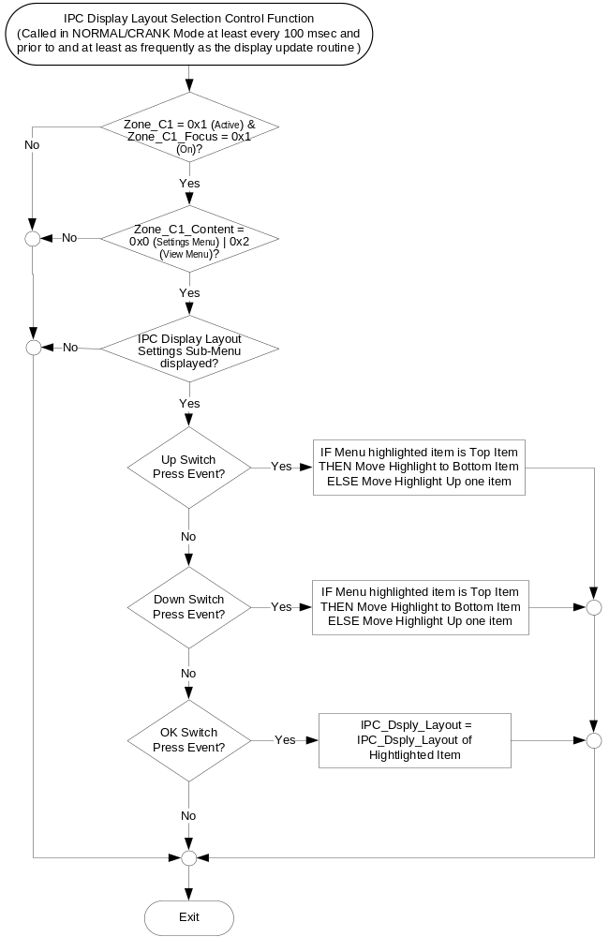

Operation Description (supports algorithm flowchart /state diagram)

- IPC_Dsplay_Layout Enabled
IPC_Dsply_Layout | Program Specific Example
IPC_Dsply_Layout | IPC_Dsply_Layout_Enabled
0x0 | 0x1
0x1 | 0x1
0x2 | IFE_Dsply_Cfg
0x3 | Fuel_Histogram_Dsply_Cfg
0x4 | Transmission_Type_Cfg
0x5 | Trailer_Brake_Cfg
0x6 | 0x0
0x7 | 0x0
- The above is an example on how to define the IPC_Dsply_Layout_Enabled array. A program specific list of IPC Display Layouts will be created. Each IPC Display Layout is assigned an IPC_Dsply_Layout value. The IPC_Dsply_Layout_Enabled array is used to determine if the corresponding IPC Display Layout will be included in the IPC_Dsply_Layout Menu list. If the value of IPC_Dsply_Layout_Enabled is equal to 0x1, the corresponding IPC Display Layout is to be included in the IPC_Dsply_Layout Menu List.
- Only IPC Display Layouts whose corresponding IPC_Dsply_Layout_Enabled value is 0x1 will be displayed in the IPC_Dsply_Layout Menu List and thus they are the only ones that can be highlighted and selected as specified in the IPC Display Layout Selection Control Function Flowchart.
- When an IPC_Dsply_Layout Menu item is selected as specified in the IPC Display Layout Selection Control Function Flowchart, the selected IPC Display Layout is displayed. This is specified in the appropriate Message Center Display STSS.

Function Safety Classification (EMC)

Class B

Memory Storage

Parameter Name | Description | Value at  Battery Connect | Value at Module Wake-up
Zone_C1 | State indicator to identify if Zone C1 is currently being displayed (Active = 0x1). | See 1 below | See 1 below
Zone_C1_Focus | State indicator to identify if Zone C1 is currently accepting button input (On = 0x1). | See 1 below | See 1 below
Zone_C1_Content | State Indicator to identify which display is currently active in Zone C1. | See 1 below | See 1 below
IPC_Dsply_Layout | State Indicator to identify which IPC Display Layout should be currently Active | 0x0 | Do Not Init
IPC_Dsply_Layout_Enabled [ x ] | State Indicator Array to identify if the associated IPC Display Layout Menu Item is present in an individual vehicle. | Program Specific | Program Specific
OK Switch Press Event | Event that is indicated as per the switch interface for the Message Center *. | See 2 below | See 2 below
Up Switch Press Event | Event that is indicated as per the switch interface for the Message Center *. | See 2 below | See 2 below
Down Switch Press Event | Event that is indicated as per the switch interface for the Message Center *. | See 2 below | See 2 below
Operational_Mode | 4 state indicator for cluster operational mode | Limited | Limited, Normal or Crank
1 Refer to the appropriate Message Center Display STSS.
2 Refer to appropriate Message Center Switch Interface STSS.

Reconfigurable Telltale

Not Applicable

Prove Out

Not applicable

Message Center Msg

Refer to text as defined in the Text Translation file.

Error Handling

No missing message strategy defined for these input signals.

Diagnostics

Self Test

None

Engineering Test Mode

None

Part II Performance

Supported Diagnostic Trouble Codes (DTCs) - None

DID DExx - None

Reference Specification
- Appropriate Message Center Display STSS
- Appropriate Message Center Switch STSS
- Appropriate Program Specific Text Translation File
- Appropriate Program Specific IPC Menu Structure File

Revision History
SPSS Module Revision History

Revision Level | Name | Change Description | Date
1.0 | T. Cwik | Initial release | 10/29/2014

